DB9,PRN : 22510064,S4

Topic : Implement concept of joins, Grouping of data and subqueries.

Q1) Answer the following Queries

Find out the product which has been sold to ‘Ivan Sayross.’

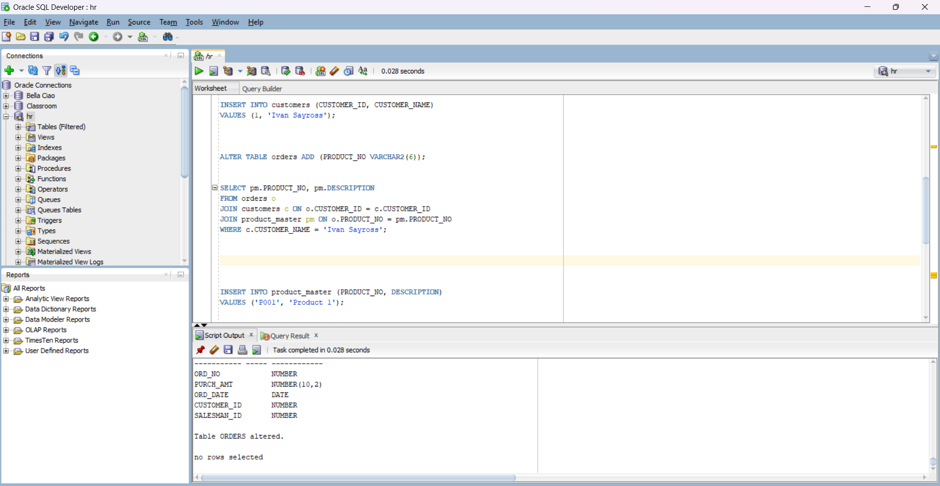

Find out the product and their quantities that will have do delivered.

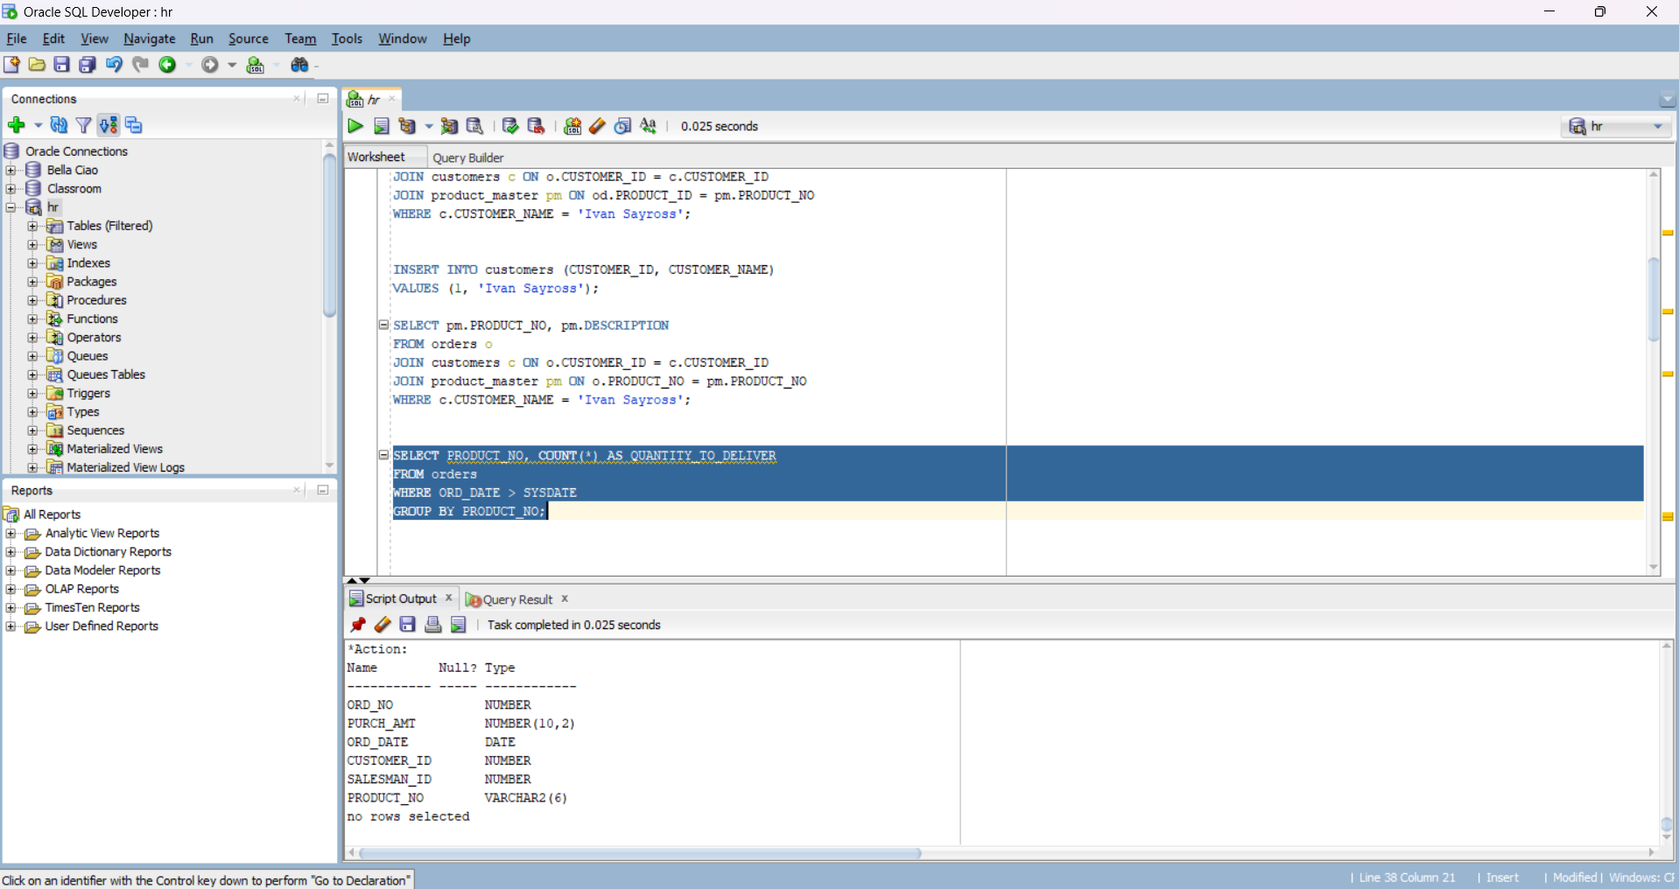

Find the product_no and description of moving products.

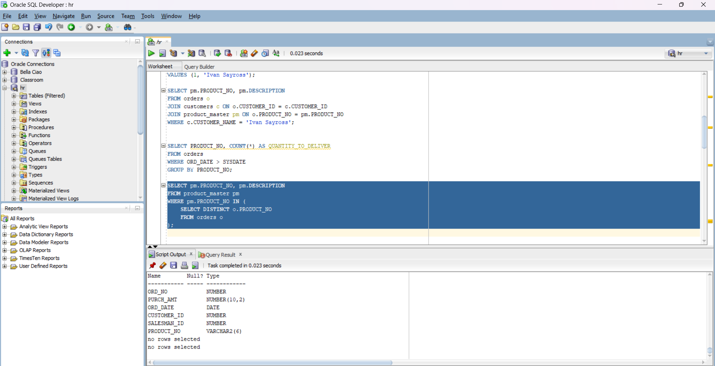

Find out the names of clients who have purchased ‘CD DRIVE’.

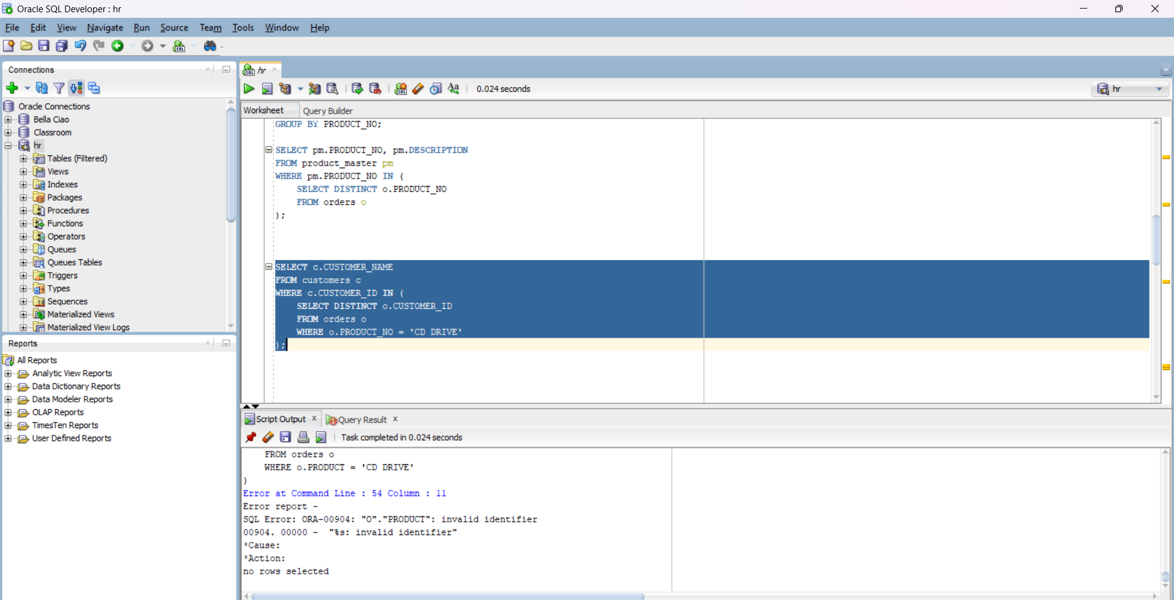

List the product_no and s_order_no of customers haaving qty ordered less than 5 from the order details table for the product “1.44 floppies”.

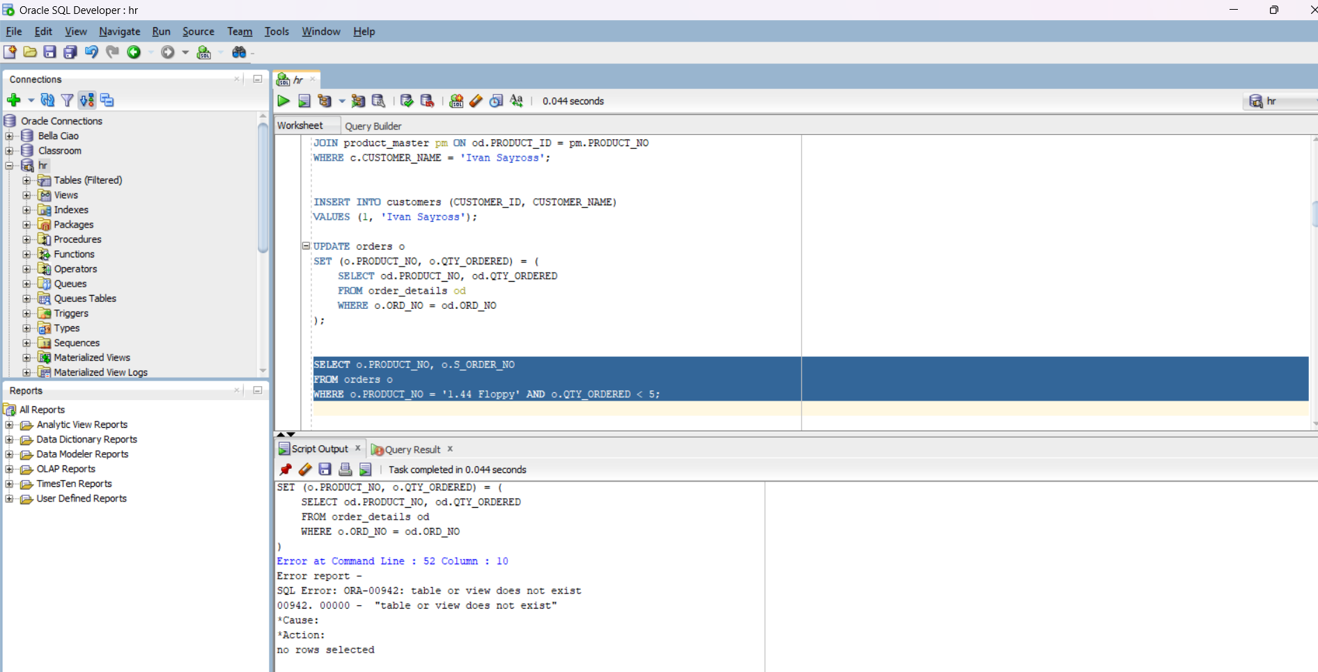

Find the products and their quantities for the orders placed by ‘Vandan Saitwal ’ and “Ivan Bayross”.

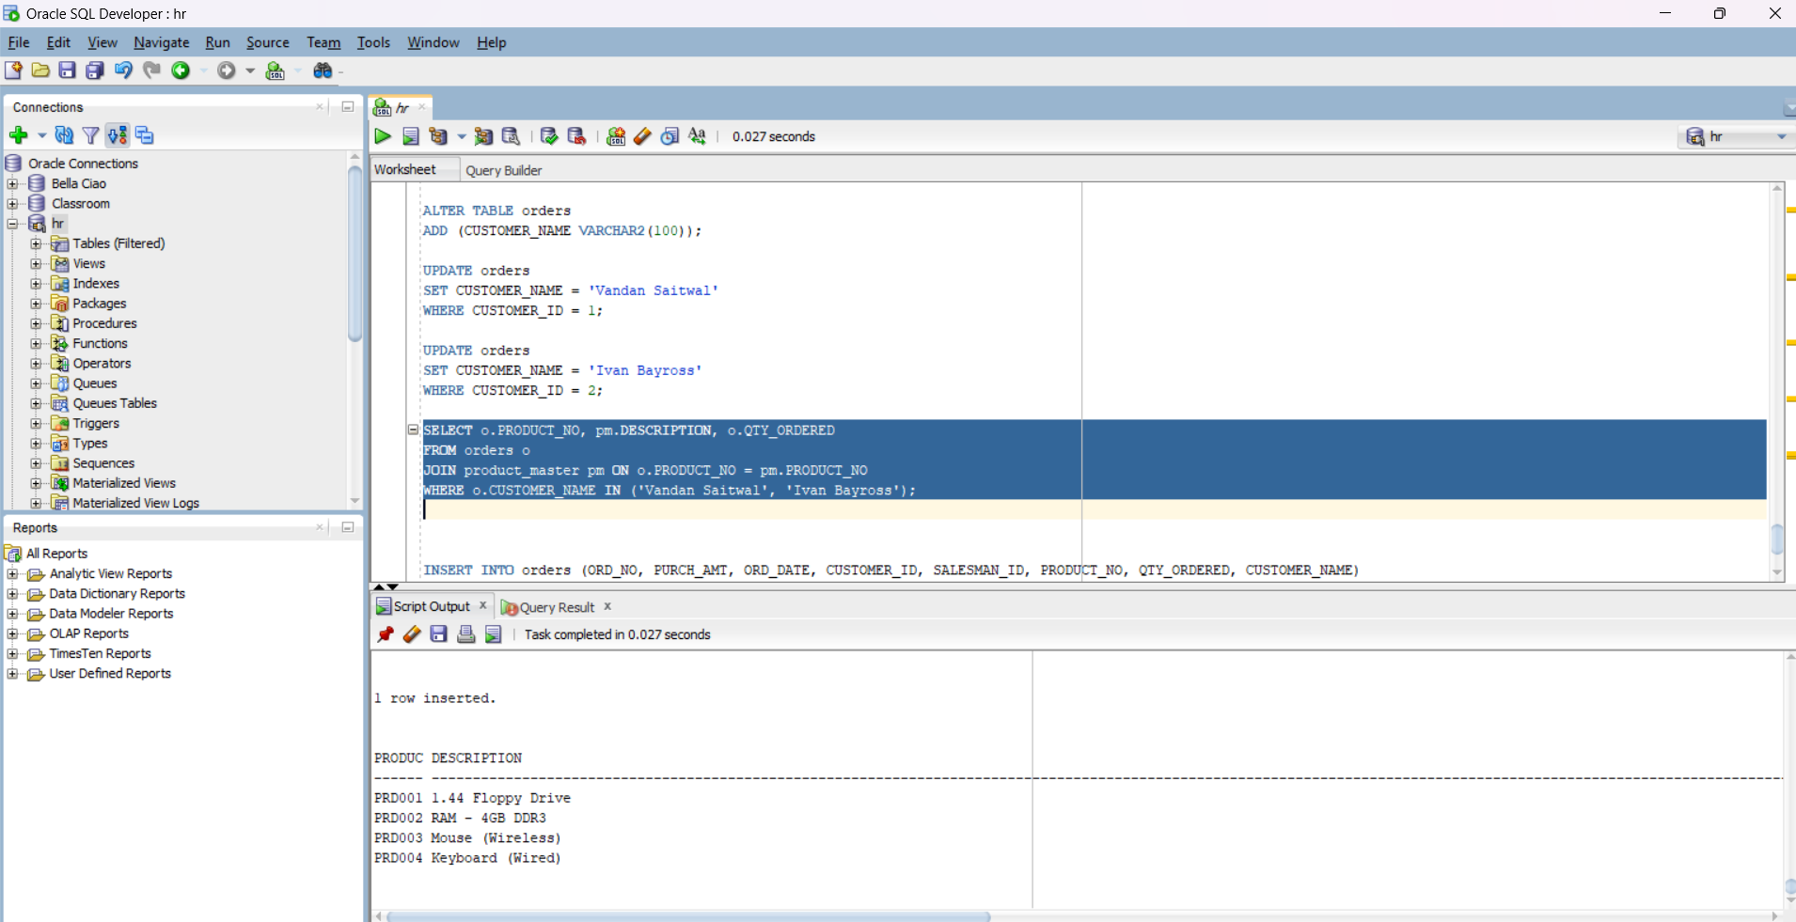

Find the products and their quantities for the orders placed by client_no “ C00001” and “C00002”

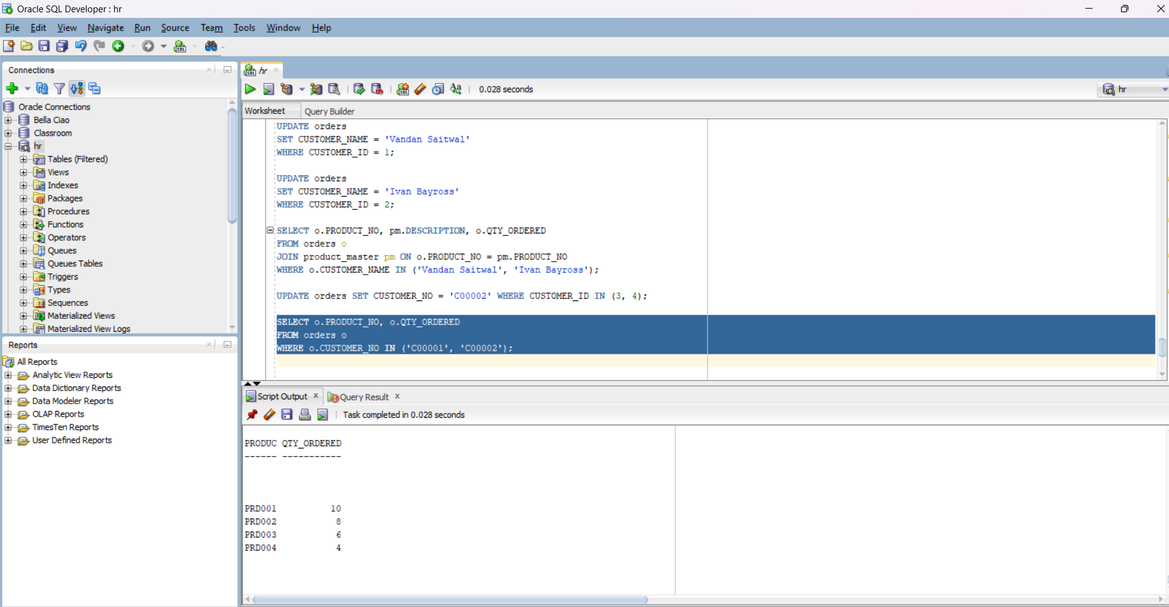

Find the order No., Client No and salesman No. where a client has been received by more than one salesman.

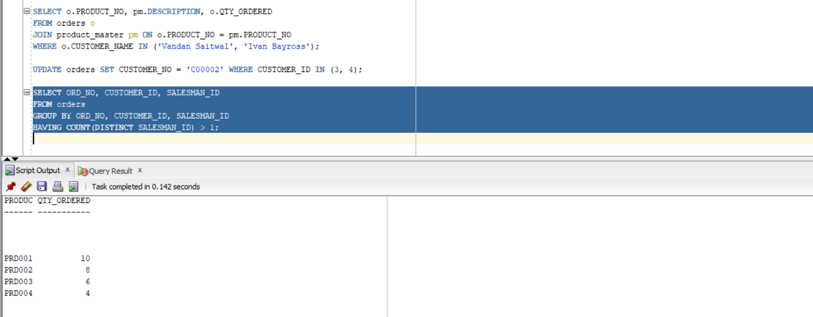

Display the s_order_date in the format “dd-mm-yy” e.g. “12- feb-96”

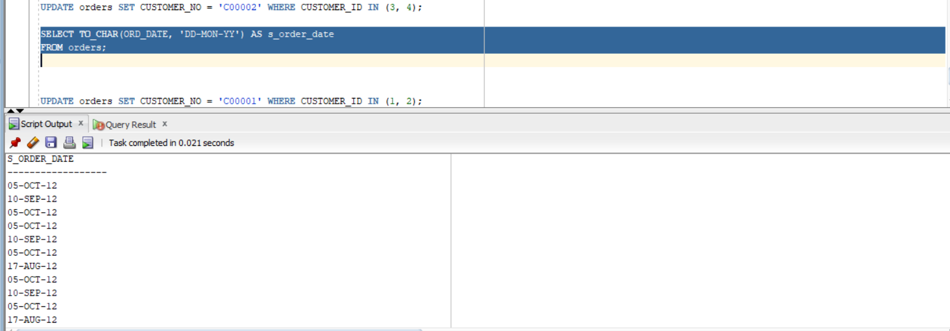

Find the date , 15 days after date.

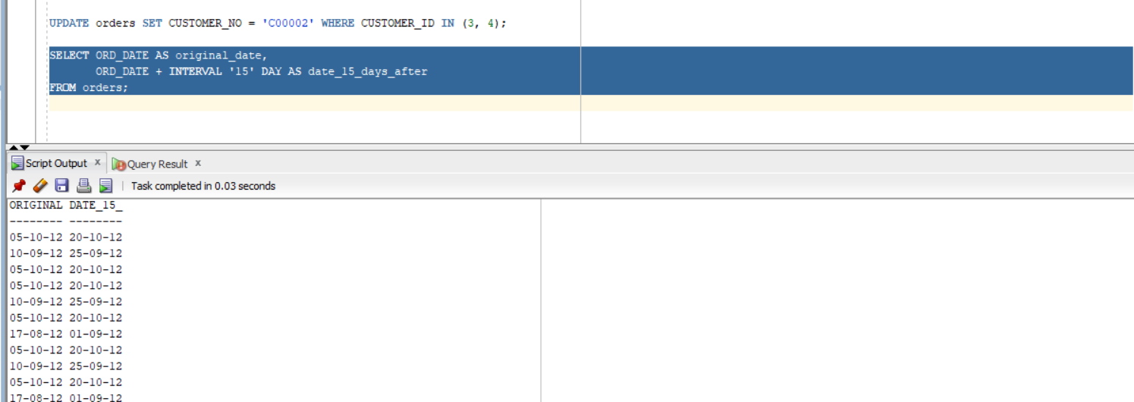

Q2) Grouping: Answer the following Queries:

1.- Print the description and total quantity sold for each product.

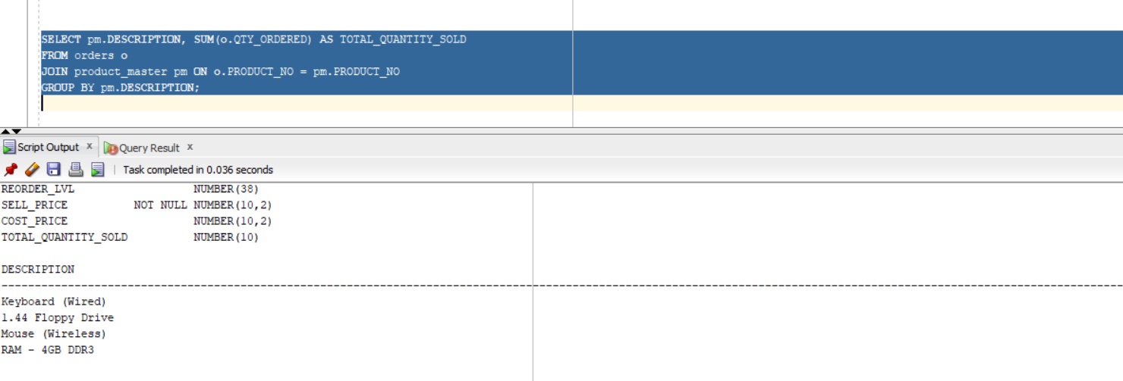

2.- Find the value of each product sold.

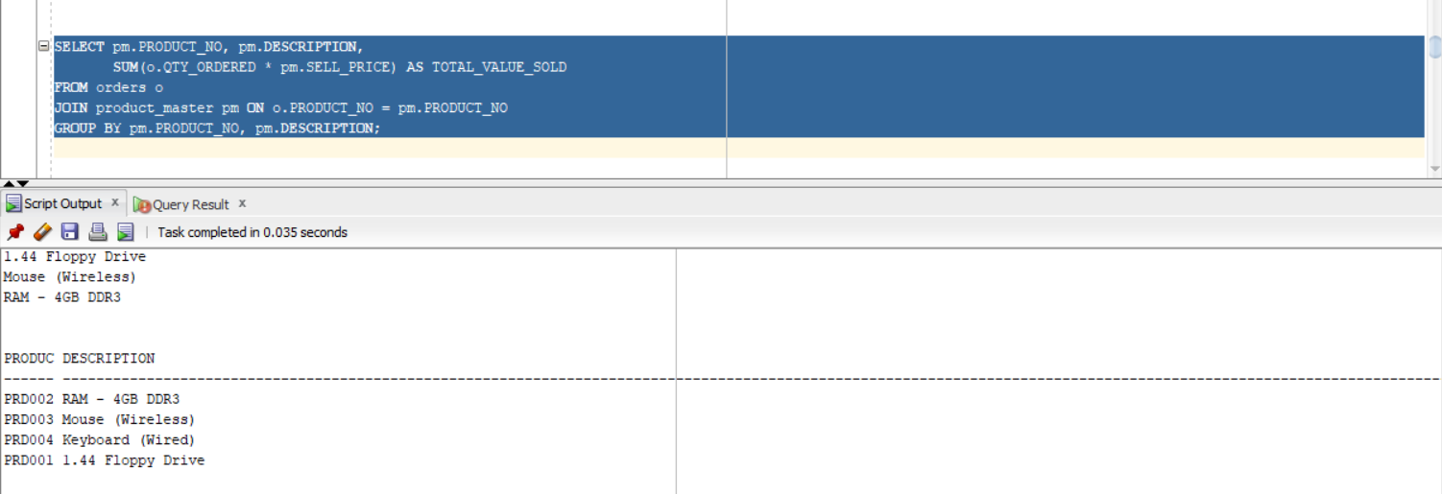

3.- Calculate the average quantity sold for each client that has a maximum order value of

15000.

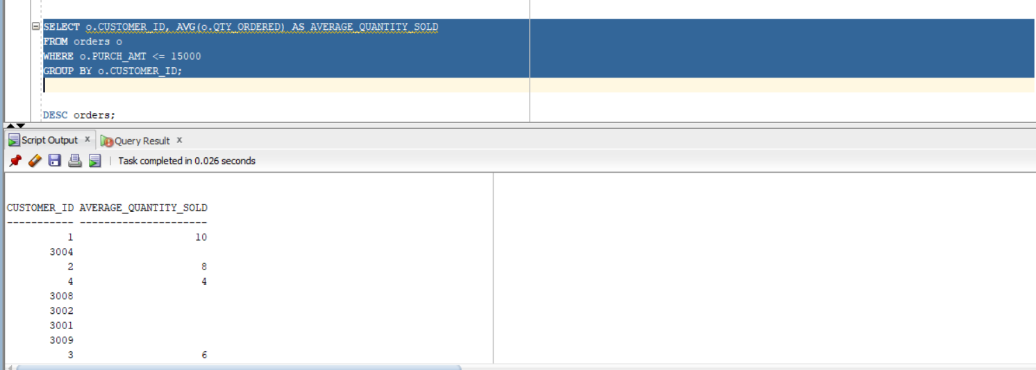

4.- Find out the products which has been sold to Ivan.

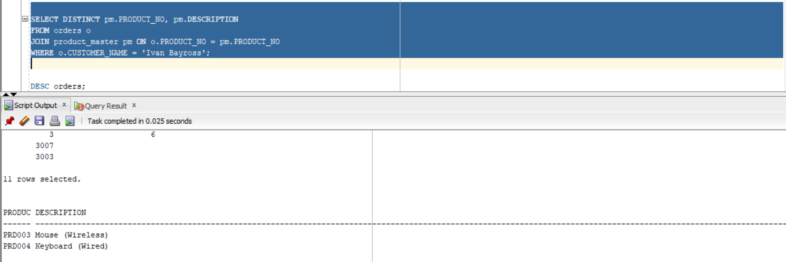

5.- Find the names of clients who have ‘CD Drive’.

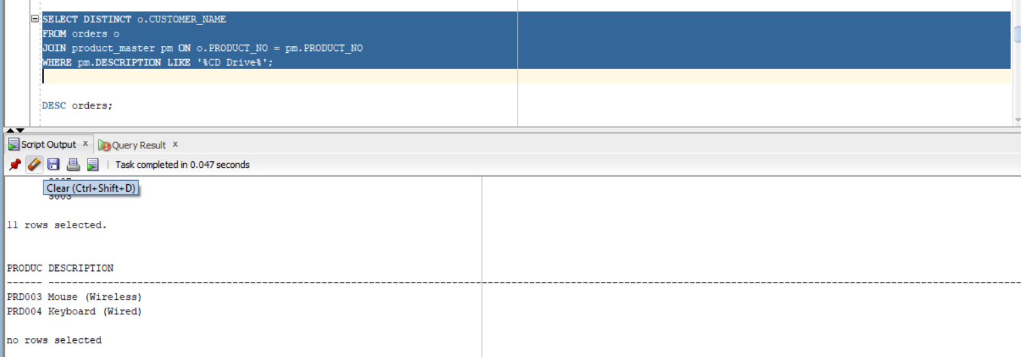

6.- Find the products and their quantities for the orders placed by ‘Vandana’ and ‘Ivan’.

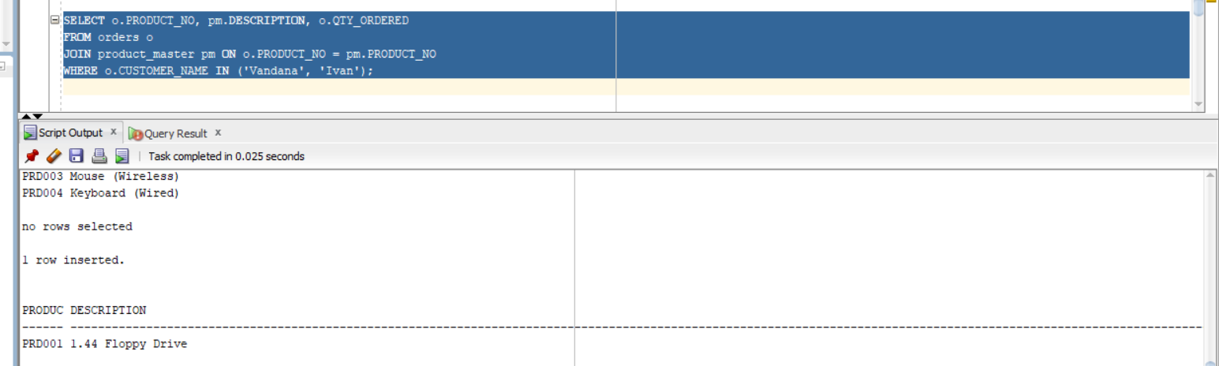

7.- Select product_no, total qty_ordered for each product.

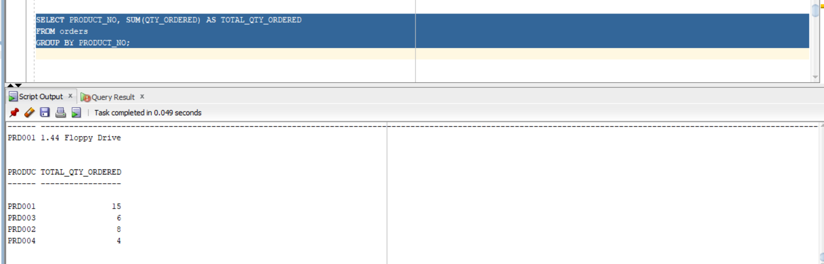

8.- Select product_no, product description and qty ordered for each product.

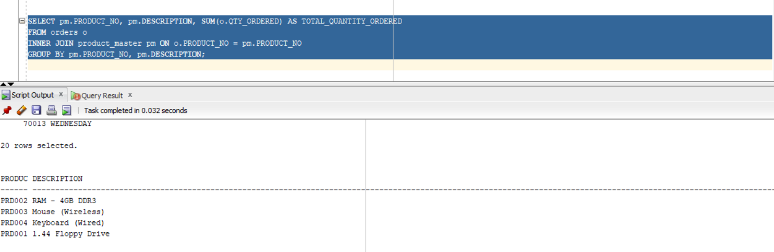

9.- Display the order number and day on which clients placed their order.

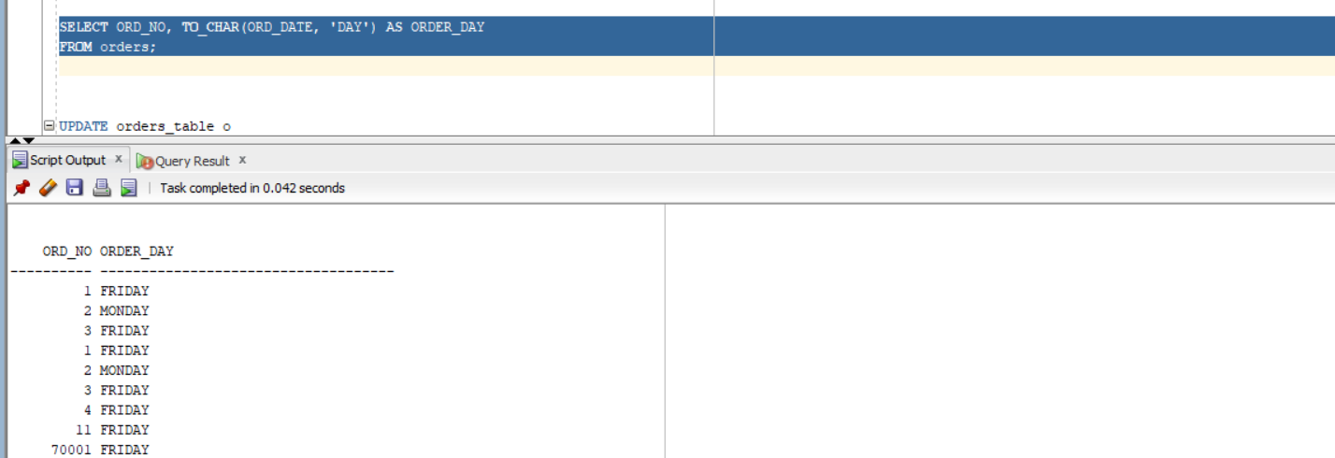

10.- Display the month and Date when the order must be delivered.

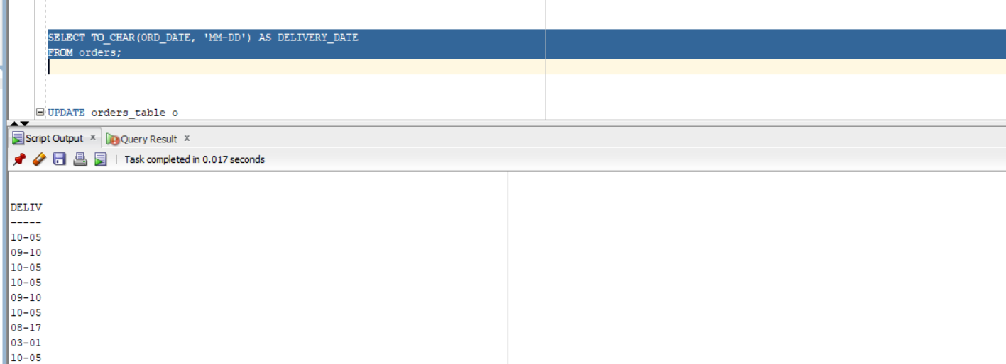

Q.3)Subqueries: Answer the following Queries:

Find the product_no and description of non- moving products

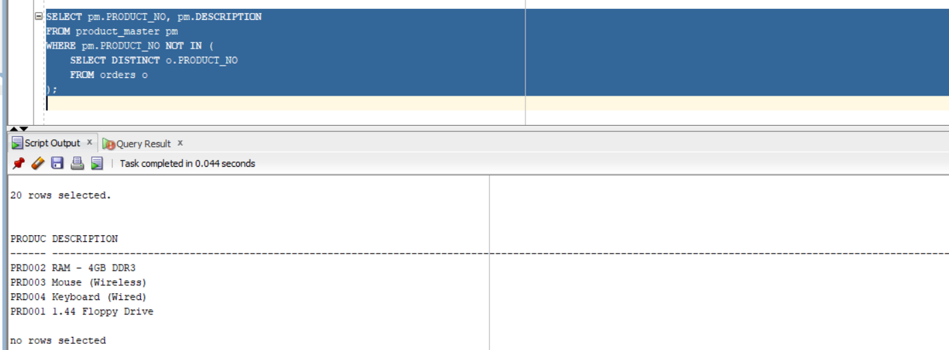

Find the customer name, address, city and pincode for the client who has placed order no “019001”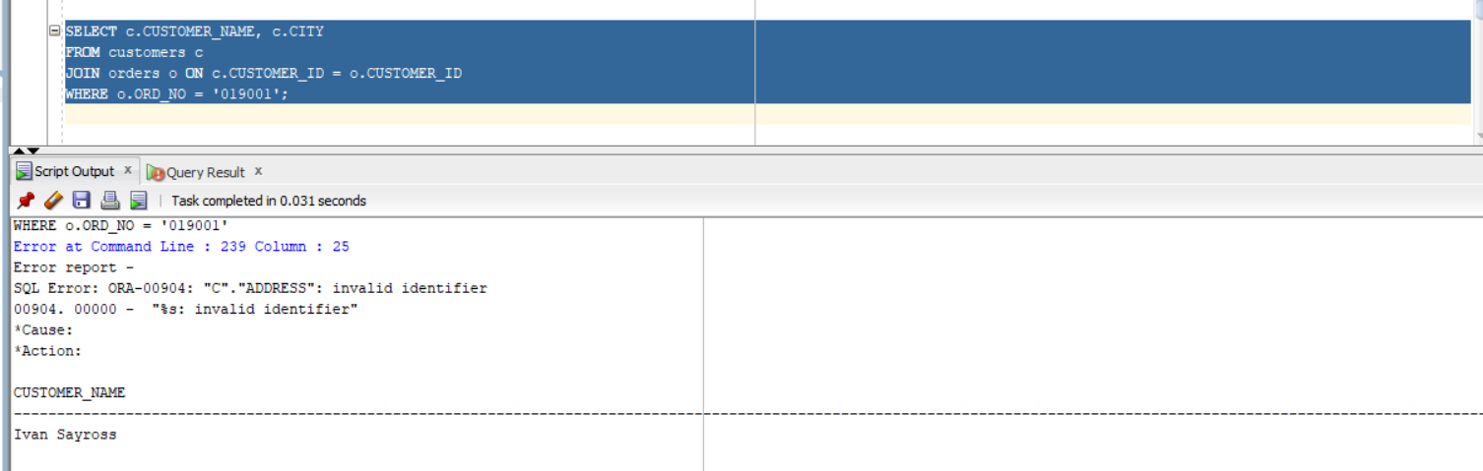



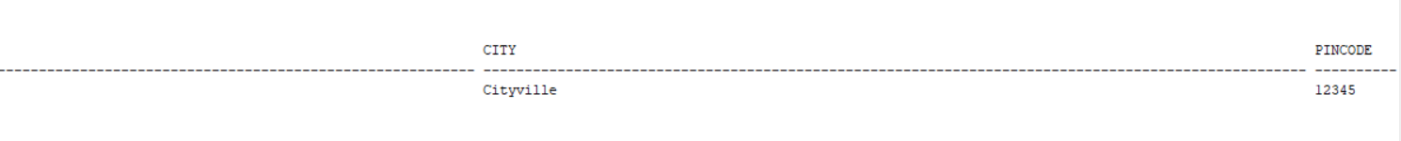

Find the client names who have placed order before the month of may 96.

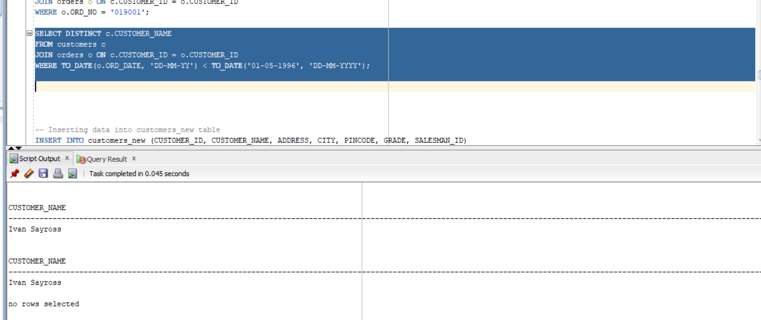

Find out if product “1.44 Drive” is ordered by only client and print the client_no name to whom it was sold.

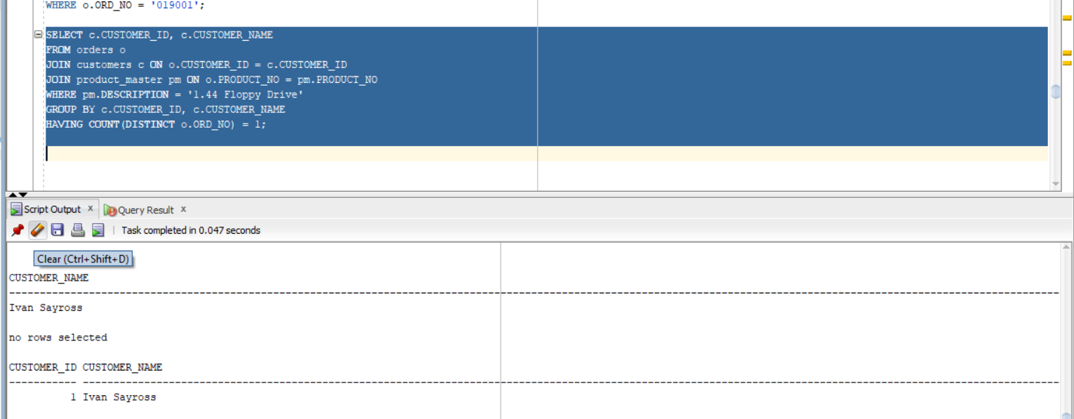

Find the names of client who have placed orders worth Rs.10000 or more.

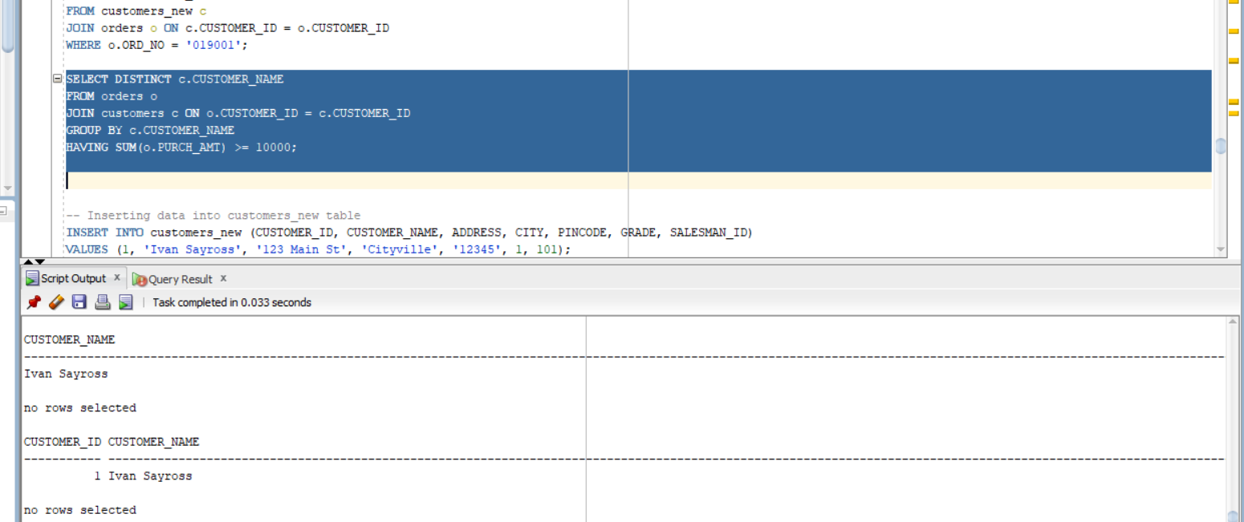

Select the orders placed by ‘Rahul Desai”

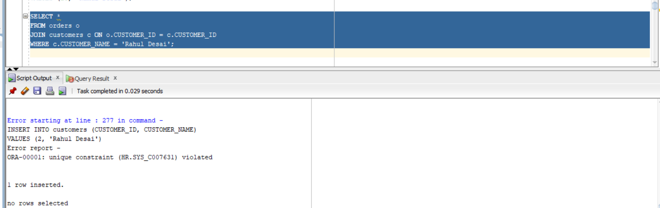

Select the names of persons who are in Mr. Pradeep’s department and who have also worked on an inventory control system.

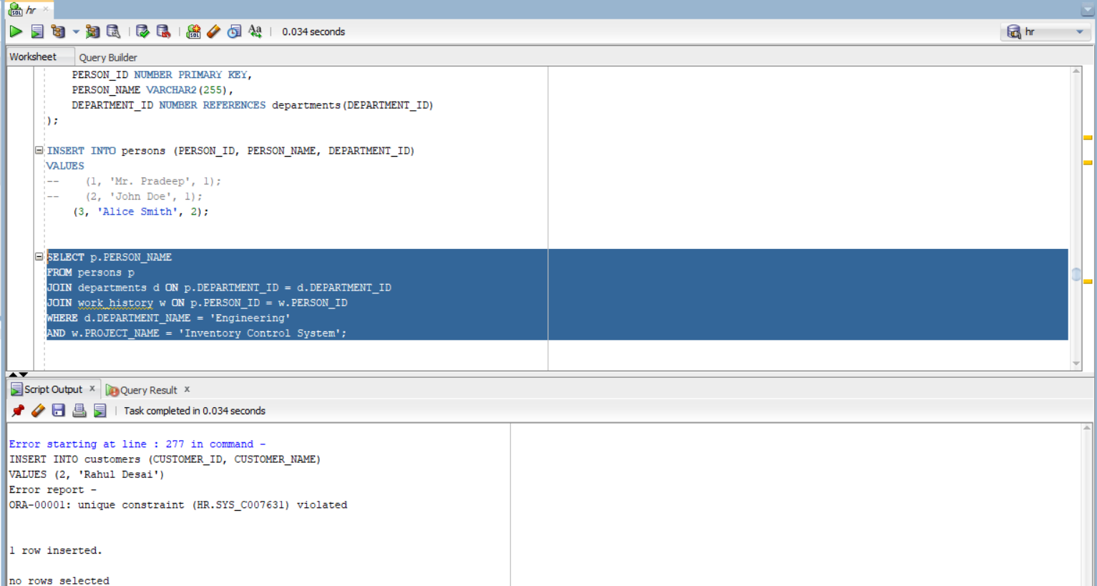

Select all the clients and the salesman in the city of Bombay.

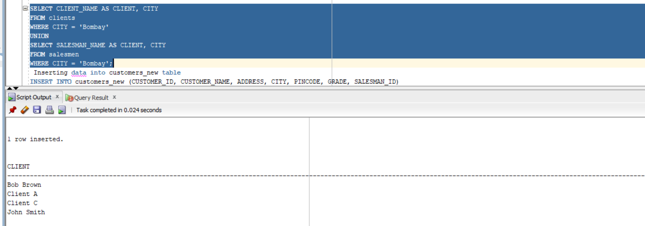

Select salesman name in “Bombay” who has atleast one client located at “Bombay”.

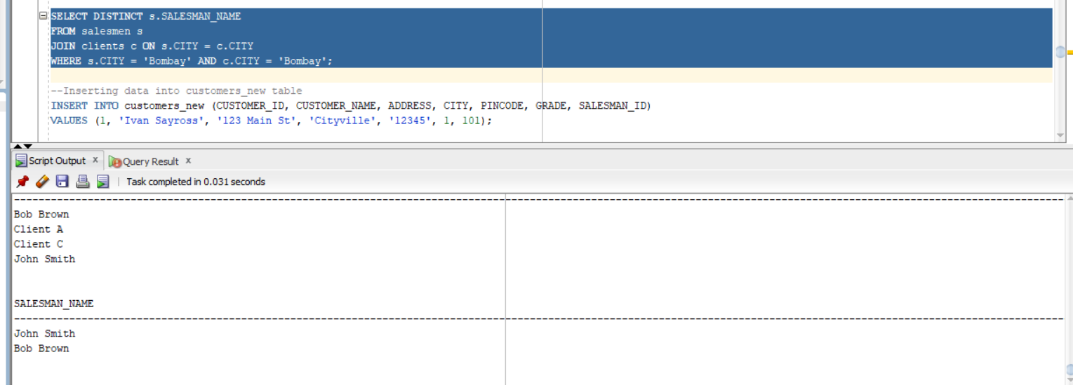

Select the product_no, description, qty_on-hand,cost_price

of non_moving items in the product_master table.

